Rozanova, Olga Vladimirovna
Born 22 June/4 July 1886, Melenki, Vladimir Province, Imperial Russia
Died 7 November 1918, Moscow, RSFSR

On finalising her art school training in Moscow in 1911, Olga Rozanova moved to St. Petersburg where she continued to study and joined the newly formed artists’ group, Union of Youth. She now belonged to that city’s first avant-garde which, in 1912, hosted painters from ‘Knave of Diamond’s and ‘Donkey’s Tail’ of the Moscow avant-garde and the Hylaea poets. Rozanova was thus at the heart of new art at its beginnings, from her Cubo-Futurism, 1912-1914, to her Suprematism, 1915-1918. In her art she was always a colourist and in search of ways of creating with it. Her discovery of spinning discs gave her a means for capturing luminous colours in the eye of the observer, which had begun by at least 1913 (Poster for Victory Over the Sun, December 1913). In 1915 she began to compose planes of transparent coloured light in tissue-paper collages using light projectors, Aleksandr Rodchenko wrote: “Wasn’t it You who designed colour compositions in the air with projectors?... You thought of creating colour through light.” In her enquiry into colour as pure colour, Rozanova was among the leading modernists and her Suprematist painting was one of the most innovative in the Russian avant-garde.

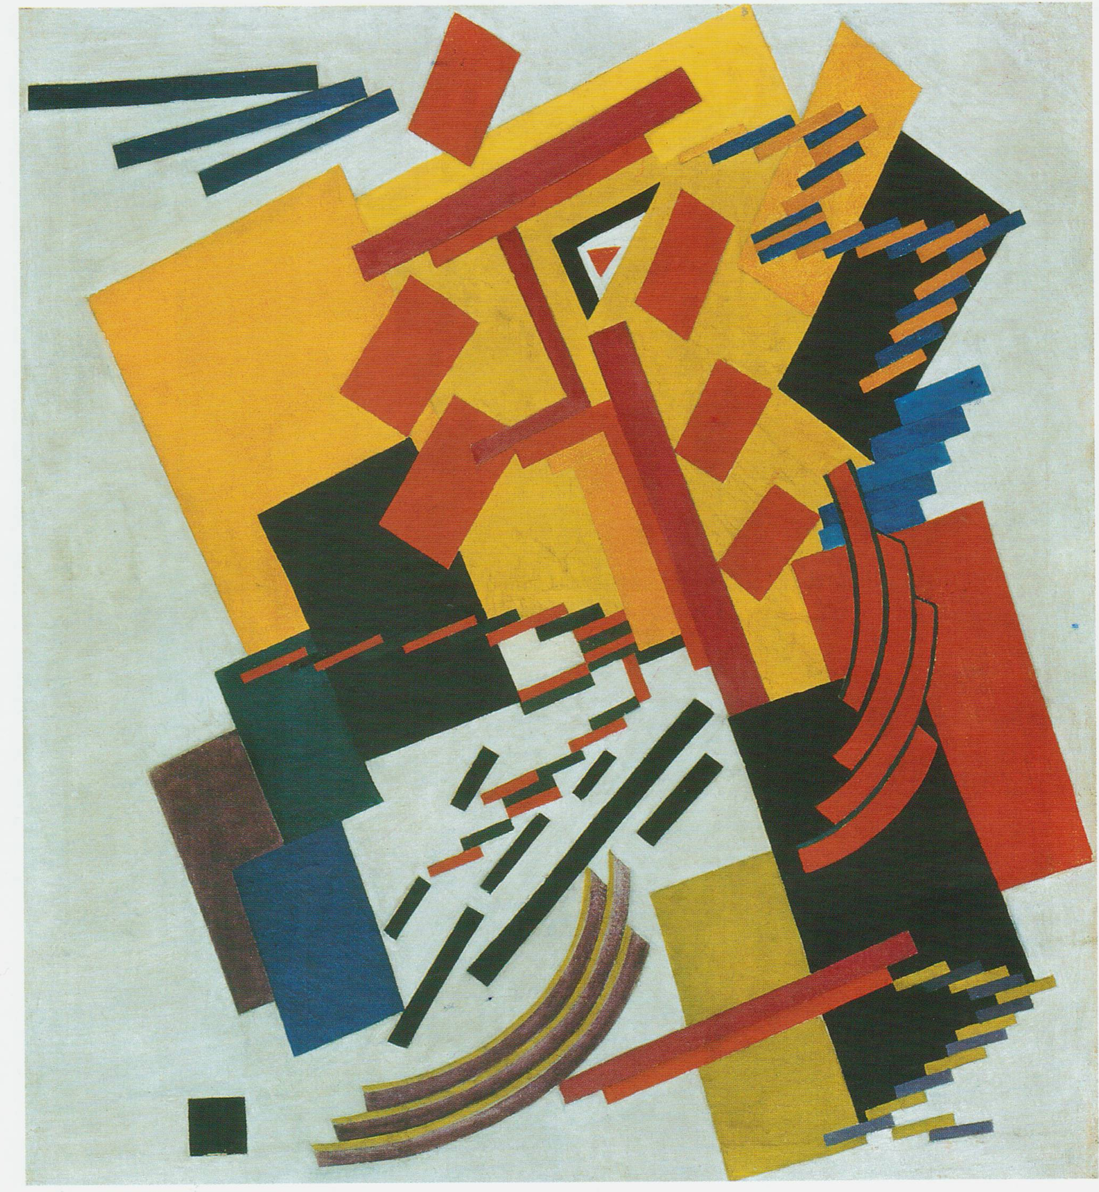
Suprematism, Oil on canvas, 90 x 74 cm. Museum of Fine Arts, Ekaterinburg

Although doing portraits and still lifes, from around 1912 Rozanova took her subject matter mainly from the city – streets, cafés, building sites, factories, a city fire, a movie theatre. Her paintings became increasingly deconstructed in order to capture the confusion of a fire or the snapshots in the eye of a prismatic flash of lights, a corner of a cobbled street, an angle of a stone building, a patch of wall paper, a lettered poster. In 1915 she went indoors, using the spinning discs to depict plates, bottles and tables in a tavern, a sewing workbox, or a hairdressers by integrating objects and planes of turning colours, catching the activity and the light. Abandoning the object around 1916, Rozanova began to paint the many optical effects and profusion of colours and textures using the discs. Her paintings were exceedingly dynamic arrangements of planes, bars and fragments filled with prismatic, spectral sequences of colours, the optical complementaries (red/green, orange/blue, yellow/violet) used to increase the dynamism. When she again took up composing with projected beams of light around 1917, Rozanova filled her canvases either with planes of colour or with a ray of a single colour over the white plane of light. Dynamism had given way to fields of luminous colour, the pure sensation of pure colour. Rozanova used the painter’s language of line, texture and plane as a visual complement to the transrational poetry of Aleksei Kruchenkh and others (1913), and she did linocut albums (Transrational Boog, 1915, War, 1916). She designed Suprematist patterns for fabrics and embroideries for the Verbovka craft initiative in 1917. Rozanova was fully engaged in the reorganisation of the craft and industrial schools in provincial Russia. She died of diphtheria in the process of hanging street decorations for the first celebration of the 1917 October Revolution.

References and further reading:
John E. Bowlt and Matthew (eds.), Amazons of the Avant-Garde, London: Royal Academy
of Arts, 1999.
Nina Gurianova, Exploring Color – Olga Rozanova and the Early Russian Avant-Garde,
1910-1918, Amsterdam: G+B Arts, 2000.

